
Egypt University of Informatics
Computer and Information Systems
Data Analysis Course

The Effect of Lockdown on COVID-19 Cases and Death Trends in Egypt

Submitted by:
24-101272 Ammar Nabil
24-101268 Khaled Elsayed
24-101018 Habiba Mohamed
24-101183 Joudy Badawi

Introduction
The outbreak of COVID-19 had a major impact on countries around the world, and this includes Egypt. As the number of cases started to rise, governments began to take precautions, and one of the most important ones was the lockdown. These lockdowns were aimed to reduce contact between people to slow down the transmission of COVID-19. This project was made to analyse whether these measures were effective or not regarding the number of cases.

This report focuses on analysing COVID-19 data in Egypt starting from February 2020. The dataset includes daily records of confirmed cases, deaths, and lockdown status. Using this data, the analysis aims to investigate two main points. First, it examines whether there is a significant difference in the number of new confirmed cases during lockdown and non-lockdown periods. Second, it explores the relationship between daily new confirmed cases and daily deaths to determine if a correlation exists between them.

Using statistical analysis, this study aims to better understand the impact of lockdown measures and the relationship between cases and deaths. The results of this study can provide insight into how effective public health interventions were during the pandemic in Egypt.

Research Question

Did lockdowns reduce COVID-19 cases in Egypt, and is there a relationship between new cases and deaths?

Main Hypothesis
Hypothesis 1:

Null Hypothesis (H₀): There is no significant difference in new confirmed cases during lockdown vs non-lockdown periods.
Alternative Hypothesis (H₁): New confirmed cases are significantly lower during lockdown periods

Hypothesis 2:

Null Hypothesis (H₀): There is no significant correlation between daily new confirmed cases and new deaths.

Alternative Hypothesis (H₁): There is a significant positive correlation between new confirmed cases and new deaths.

Sub Hypothesis
Numerical Variables:
- Active cases vs new recovered

  - H₀: active_pos has no significant relationship with new_recovered.
  - H₁: Higher active_pos is associated with higher new_recovered.
- New Confirmed Cases vs New Deaths

  - H₀: here is no significant relationship between daily New_Confirmed and New_Deaths.
  - H₁: There is a positive relationship between daily New_confirmed and New_Deaths.
- New Confirmed Cases and New Recoveries

  - H₀:Daily New_Cases have no significant relationship with New_Recoveries.
  - H₁: Higher daily New_Cases are associated with higher New_Recoveries.
- Cases in hospital vs New deaths

  - H₀: cases_in_hospital has no significant relationship with new_deaths.
  - H₁: Higher cases_in_hospital is associated with higher new_deaths.
Categorical Variables:
- Lockdown vs new confirmed cases
  - H₀: Lockdown status (lockdown) has no significant effect on new_confirmed.
  - H₁: Lockdown is associated with lower new_confirmed.

Population of Interest:
The population of interest includes all COVID-19 daily observations in Egypt starting February 2020. This means all the recorded daily data such as the number of confirmed cases, deaths, recoveries, and other related COVID-19 statistics. The dataset helps us understand how the virus changed and spread over time in Egypt, and it is mainly used for analysis and finding trends. The data was taken from Kaggle.

Sampling Method:

The dataset was sourced from Kaggle and can be considered a form of convenience sampling, as the data was already publicly available and collected from existing records rather than being randomly sampled by the researcher. This means the observations were included based on availability rather than through a controlled random selection process. While this approach makes the data easy to access and useful for analysis, it may introduce bias and limit how well the results can be generalized to all COVID-19 cases in Egypt. However, it is still suitable for exploratory data analysis and identifying trends over time. For more accurate and generalizable conclusions, future studies could use more structured sampling methods such as random or stratified sampling.

Bias Identification:
Convenience Sampling Bias
The dataset is taken from Kaggle, and it was not collected using a random sampling method. Instead, it is based on data that was already available publicly. This means the observations were included based on convenience rather than a structured selection process. As a result, the dataset might not fully represent all COVID-19 cases in Egypt, which can limit how generalizable the findings are.
Self-Reported Data Bias
While the data is not directly self-reported by individuals, it relies on reports from institutions such as hospitals and health authorities. These reports may still contain errors, delays, or inconsistencies in recording cases, deaths, and recoveries, which can affect the accuracy of the dataset.
Omitted Variable Bias
The dataset does not include other important influencing factors such as vaccination rates, government restrictions, healthcare capacity, or population density. Because of these missing variables, the analysis may not fully explain all the reasons behind the observed COVID-19 trends.
Cultural Context Bias

The dataset does not provide detailed information about regional, social, or economic differences within Egypt. Without this context, it is harder to fully interpret the results or apply the findings accurately across different areas of the country.

Collected Data/Dataset:
The dataset used for this project is titled “Egy-COVID-19” and contains time-series data related to the spread and impact of COVID-19 in Egypt. It includes daily recorded information on confirmed cases, recoveries, deaths, and healthcare system indicators, along with government intervention measures such as lockdown status.
The dataset captures the progression of the pandemic over time and provides both cumulative and daily metrics, allowing for trend analysis and evaluation of public health responses.
The key variables include:
Numerical variables:
- date (recorded day of observation)
- new_confirmed (daily new confirmed cases)
- new_deaths (daily deaths)
- new_recovered (daily recoveries)
- new_pos_to_neg (daily transitions from positive to negative)
- active_pos (currently active cases)
- cases_in_hospital (number of hospitalized cases)
- total_confirmed (cumulative confirmed cases)
- total_deaths (cumulative deaths)
- total_recovered (cumulative recoveries)
- total_pos_to_neg (cumulative positive to negative cases)
- lockdown_duration (number of days under lockdown)
- deathrate (proportion of deaths relative to confirmed cases)
- lockdown_Yes (binary indicator of lockdown status)
Categorical variables:
- lockdown( Yes/No)
Number of samples used: 85

Analysis:
Descriptive Statistics Analysis
Dataset Size: 85 daily observations (Egypt)

This analysis explores the progression of COVID-19 in Egypt by examining relationships between daily cases, recoveries, deaths, and the impact of lockdown measures over time. The dataset includes both daily and cumulative indicators, allowing for a comprehensive understanding of pandemic trends.

1. Factors Hypothesized to Have Effect

1.1: This graph compares the average number of new confirmed cases between lockdown and non-lockdown periods.
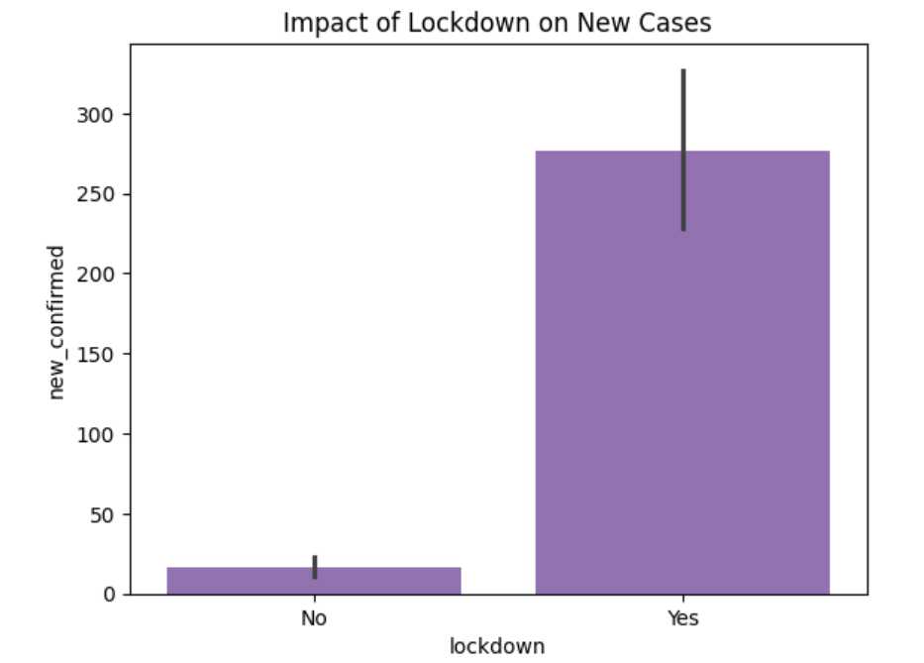
This shows that the lockdown impacts the number of cases heavily as the difference between Yes and No is high.
1.2: This graph shows the distribution of new confirmed cases for lockdown and non-lockdown groups.
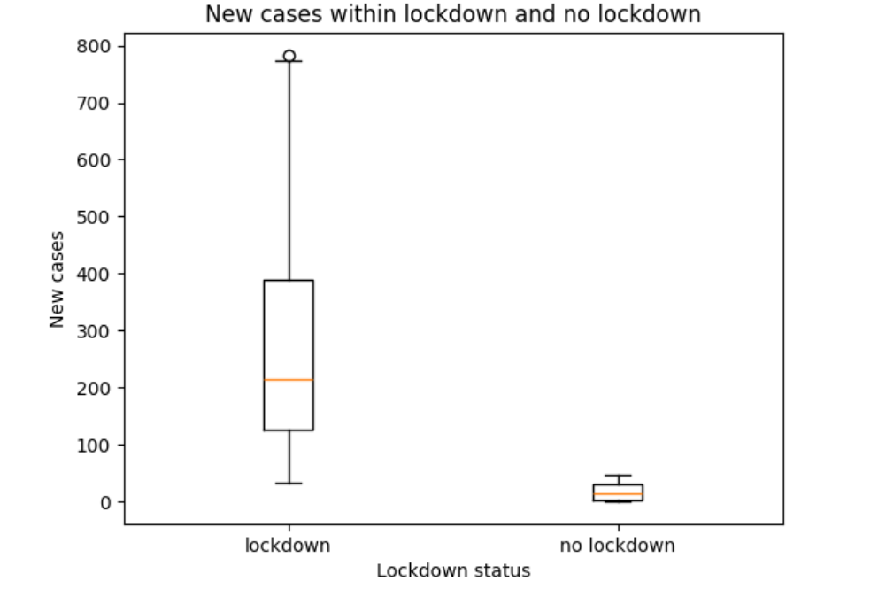
Interpretation:
- According to the boxplot. After the lockdown started the number of new cases were still increasing and the rate did not slow down which means that the lockdown had a negative effect.
1.3: This illustrates the relationship between new confirmed cases and new deaths.
1.4: This Linear regression line shows the relationship between variables along with a fitted regression line.
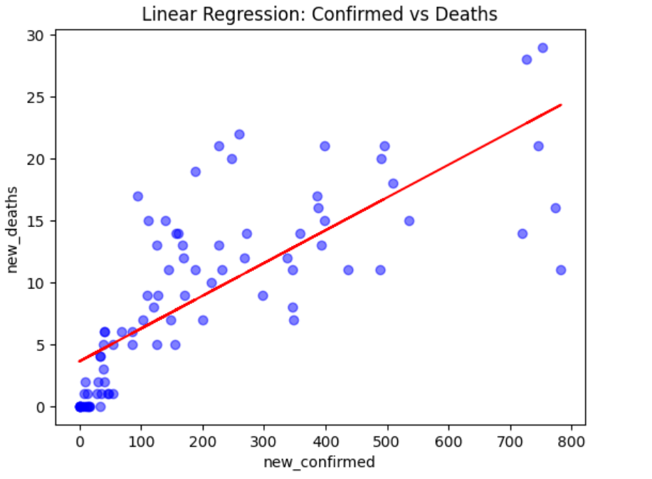
Interpretation:
There is a positive linear relationship between confirmed cases and deaths, meaning higher infection levels generally correspond to more deaths. However, the spread of points shows that cases alone are not sufficient to accurately predict deaths, and other factors (time lag, healthcare quality, demographics, reporting) likely play a significant role.
2.Factors Hypothesized to Have No Effect
2.1:This graph provides a visual summary of the initial COVID-19 trajectory in Egypt, covering the period from March 2020 through mid-May 2020. It effectively illustrates the transition from early cases to an upward trend in viral transmission.
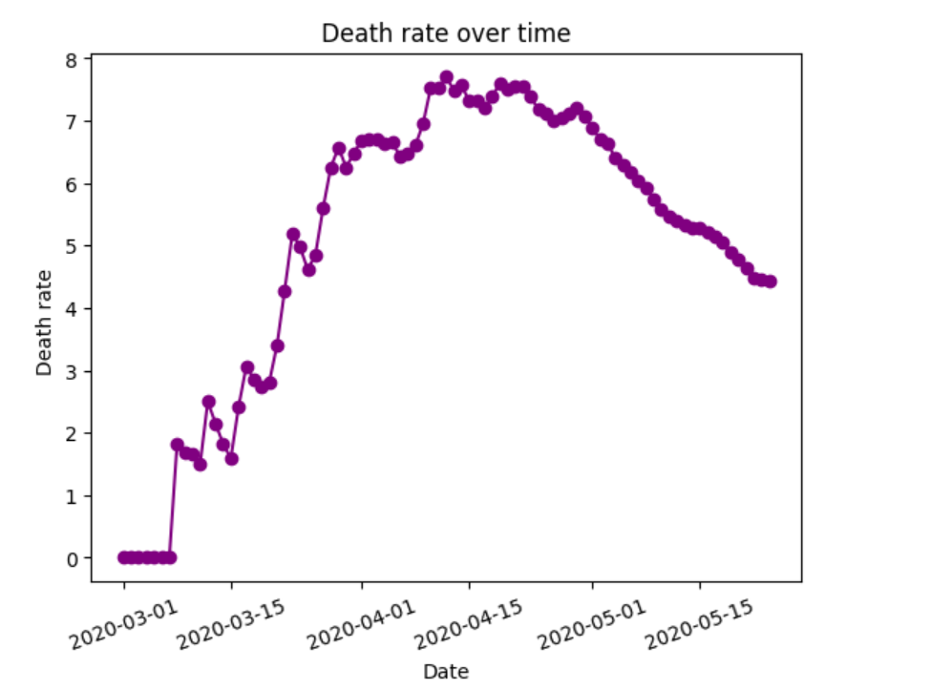
Interpretation:
- Initial start (March 1 – March 10): In the beginning, the line is flat. There were no cases, and it seemed like the virus hadn't spread yet.
- The virus started spreading more and the death rate increased rapidly over a few days (March 10 – March 12)
2.2: This illustrates the relationship between new confirmed cases and new deaths.
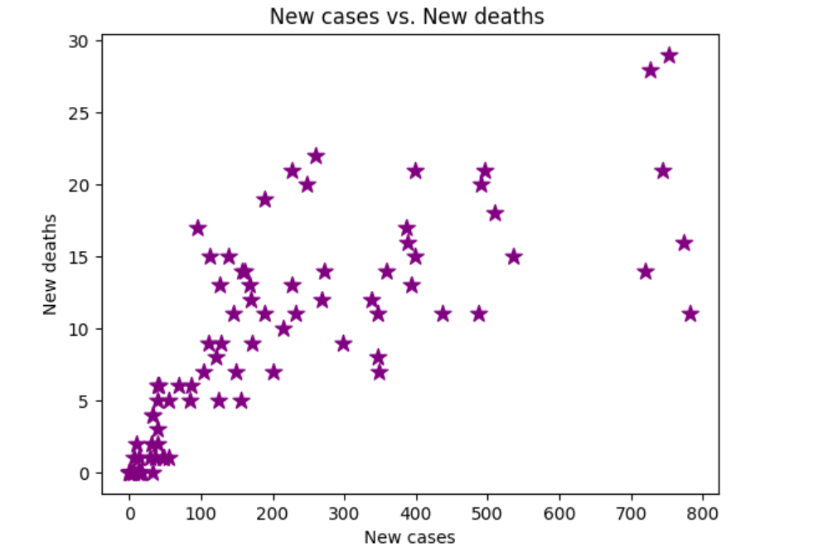
The scatter plot shows a positive relationship between new confirmed cases and new deaths, where higher numbers of cases are generally associated with higher numbers of deaths.However, the points are somewhat spread out, indicating that the relationship is not perfectly consistent and may be influenced by other factors.

The Death rate gradually started rising after that starting from around March

2.3: This graph represents the number of new COVID-19 cases recorded over time.
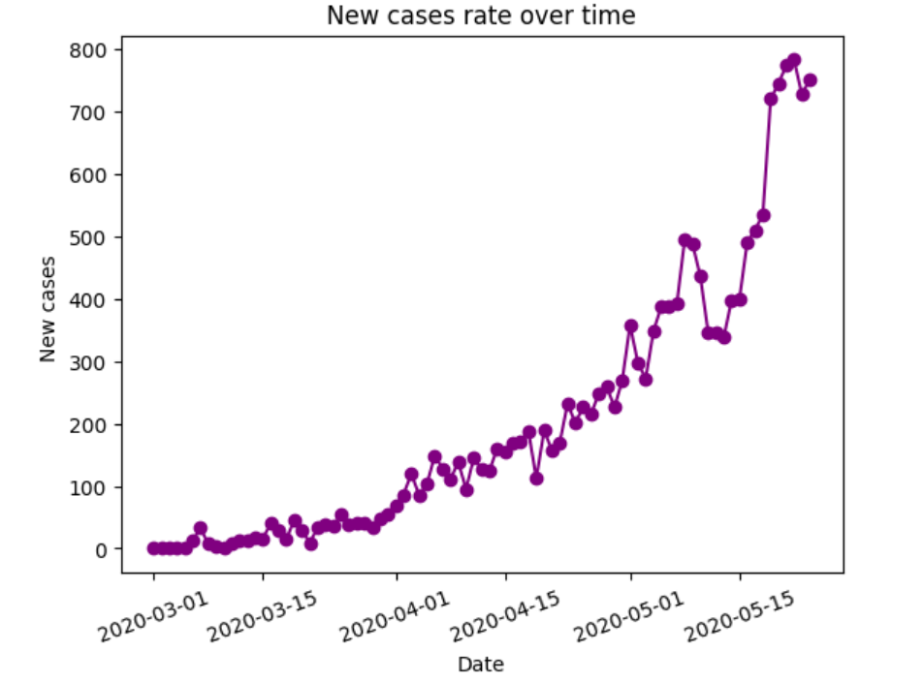
Interpretation:
- The number of cases were increasing slowly for about 2 months starting from 1st of March till 1st of May. After that the number of cases grew by an increasing rate. This means that the lockdown did not affect the amount of cases.

2.4: This correlation heatmap displays correlation values between variables in a matrix format.
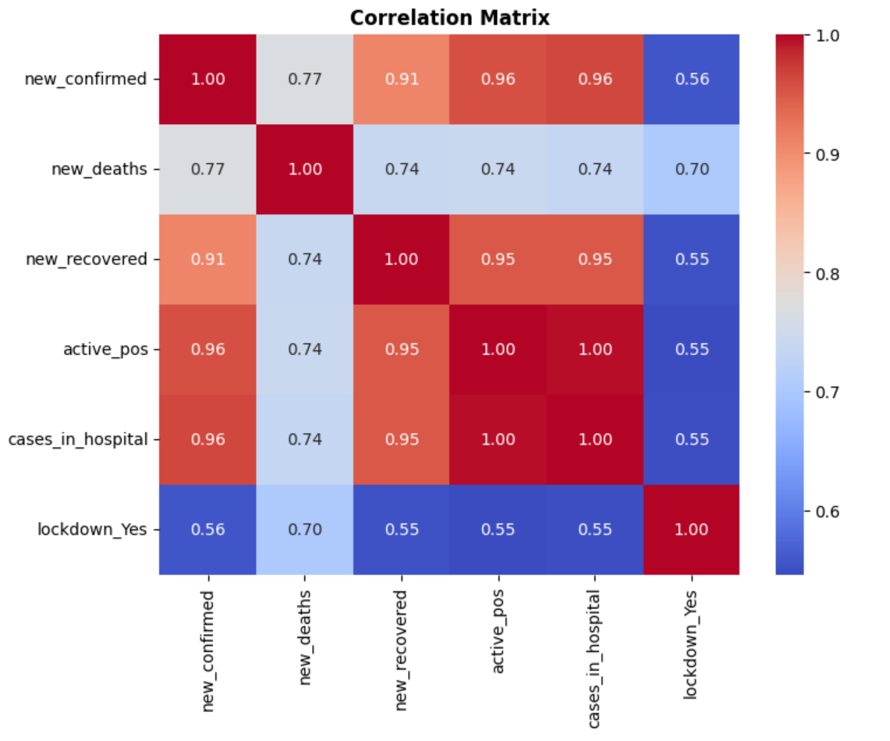
The heatmap shows a strong positive correlation between new confirmed cases and new deaths, indicating that higher numbers of cases are associated with higher numbers of deaths. There is also a positive relationship between active cases and new confirmed cases, showing that increases in daily infections are associated with higher numbers of active cases. Variables like new recovered cases also show positive correlations with cases, reflecting that recoveries tend to increase as total infections increase. In contrast, the lockdown variable shows a weak correlation with most variables, suggesting that its relationship with case numbers is not strongly linear in the dataset.

Hypothesis Testing Steps

Step 1: Define null and alternative hypothesis
Step 2: Choose the appropriate test
Step 3: Calculate the p-value
Step 4: Determine the statistical significance
Hypothesis Test 1
Lockdown period effects on confirmed cases
Step 1:
H₀: There is no significant difference in new confirmed cases during lockdown vs non-lockdown periods.
H₁: New confirmed cases are significantly lower during lockdown periods.

Step 2:
since im comparing new_confirmed which is numerical between two groups with a small sample size we apply t-test
Step 3:
The calculated statistics are:
T-statistic: 6.089284228789215
3.382821785409008e-08

Step 4:
Since the p-value is significantly smaller than the standard significance level of 0.05, we reject the null hypothesis. This proves that the lockdown has a significant effect on the number of cases.

Hypothesis Test 2
Relation between confirmed cases and daily deaths
Step 1:
H₀: There is no significant correlation between daily new confirmed cases and daily new deaths.
H₁: There is a significant positive correlation between new confirmed cases and new deaths.

Step 2:
since im examining the correlation between two numerical values we apply Pearson test
Step 3:
The calculated statistics are:
Correlation: 0.7662473222011862
P-value: 1.2859892882614822e-17

Step 4:
Compare the p-value to the Correlation. The correlation is significantly higher than the p value which means we reject H0

Conclusion
This study analyzed COVID-19 data in Egypt in order to evaluate the impact of lockdown measures on daily confirmed cases and to examine the relationship between cases and deaths. Two statistical methods were applied to test the hypotheses: an independent samples t-test for the effect of lockdown status on new confirmed cases, and Pearson correlation for the relationship between daily confirmed cases and daily deaths.
The results of the t-test showed a statistically significant difference in the number of daily confirmed cases between lockdown and non-lockdown periods, leading to the rejection of the null hypothesis. This suggests that lockdown measures had a significant effect on changing the number of new COVID-19 cases in Egypt.
In addition, the Pearson correlation test indicated a significant positive relationship between daily confirmed cases and daily deaths. As a result, the null hypothesis was also rejected for the second test, meaning that increases in confirmed cases are associated with increases in deaths.
Overall, the findings suggest that lockdown measures played an important role in influencing the spread of COVID-19, and that there is a clear relationship between case numbers and mortality. These results highlight the importance of public health interventions in managing pandemic outcomes in Egypt.

Potential Issues
During the course of this analysis, several potential issues and limitations were identified:
- Small dataset size: The dataset contains a relatively small number of observations. ( 85 observations). This limits the statistical power of hypothesis tests and may reduce the reliability of conclusions.
- Limited Variables: The dataset only includes a few variables (cases, deaths, recoveries, lockdown, etc.). This can lead to omitted variable bias.
- Correlation ≠ Causation: The analysis identifies relationships between variables using correlation. However, correlation does not imply causation, meaning that a relationship between two variables does not necessarily indicate that one causes the other.
- Lockdown Variable Simplification: The lockdown variable is treated as a simple Yes/No value. This simplification may reduce the accuracy of conclusions.
- Limited Hypothesis Testing: Only a small number of hypotheses were formally tested. Some relationships (from the heatmap) were not statistically validated.

